Lab 2

CS 5-1 - BSCS – Operating System Lab

Name: Sharaiz Ahmed SAP: 57288

Task1 — Emulators & Software-Defined Hardware
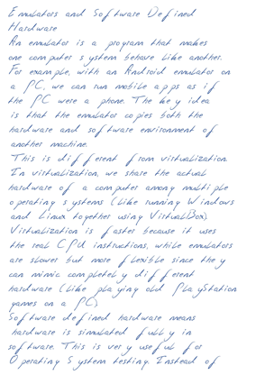
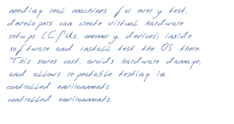
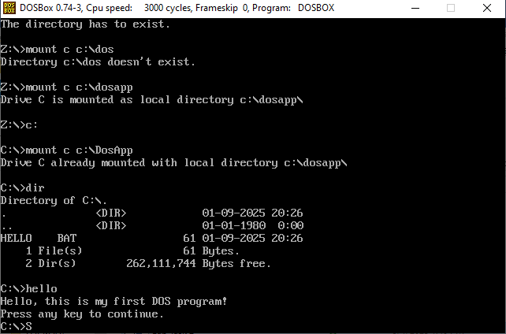

Task 2 — Shell & Terminal Relationship
Shell:
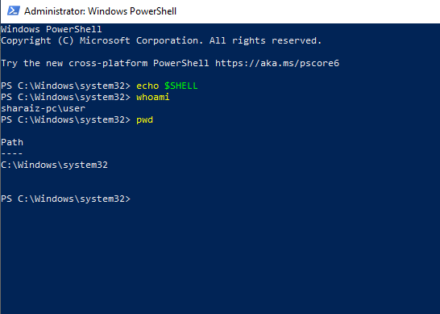
TTY:
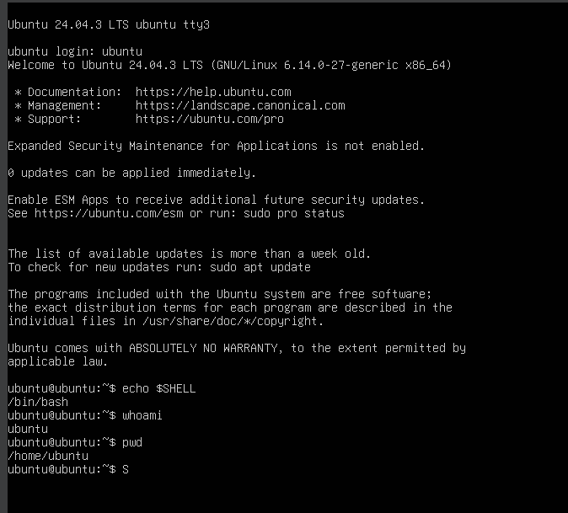
Shell & Terminal Relationship
A terminal is just an interface that lets us interact with the system. The GUI terminal is a terminal emulator, while a TTY is a real text console provided by the OS.
A shell e.g. Bash is the program that actually interprets our commands inside the terminal. For example, when we type pwd, the shell translates it into system calls that the OS understands.
Importance of Shells:
Shells are important in OS design because they provide a command-line interface (CLI) for controlling processes, managing files, and interacting directly with the kernel. They allow scripting, automation, and system management, which makes them powerful for both users and administrators.

Task 3 — Remote Access & SSH

List of SSH Commands used:
- ssh student@127.0.0.1 – For connecting to a local or remote system.
- scp file.txt student@127.0.0.1:/home/student/ - Copies file from local to remote
- ssh-keygen – This generate SSH key pair.
- ssh-copy-id student@127.0.0.1 – It will copy public key to server
- ssh student@127.0.0.1 – This will connect it without password.

Secure Remote Login with SSH:

SSH (Secure Shell) is a tool that lets us safely connect to another computer over a network. It is mostly used to log in to remote systems and move files from one machine to another.

- Encryption: Everything you type or send is scrambled, so no one can spy on your passwords or commands.
- Authentication: SSH checks that you are really you and that the server you’re connecting to is the right one.
- Integrity: It makes sure that whatever you send (like commands or files) is not changed or broken along the way.

Because of these reasons, SSH is one of the safest and most trusted ways to manage computers from far away, share files, and run scripts.

